3.78: A direct way to find the angle is to consider the velocity relative to the air and the velocity relative to the ground as forming two sides of an isosceles triangle. The wind direction relative to north is half of the included angle, or 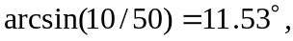 east of north.

